MD. MIGNIUR RAHMAN | 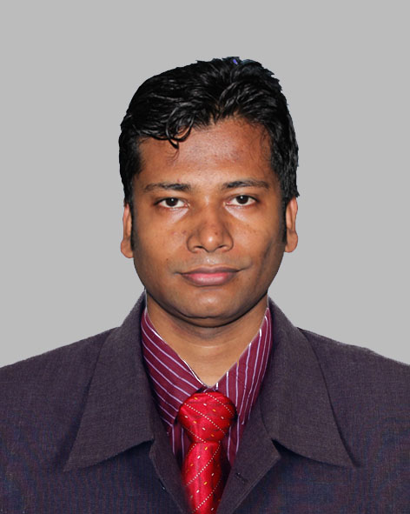
Address: House# 17, Road#02, Pakpara, Rangpur, Bangladesh.
Home Phone: 01723997962
Office Phone :01723997962
Mobile : 01723997962
Skype: konok0071
e-mail : konoknew@gmail.com, konok@kurigram.net

Career Objective:
Web Developer & Designer HTML5, CSS3, Javascript, Photoshop, gif, mainainable code,PHP,Wordpress.

Career Summary:
Willing to work in a career based on national or international organization where success comes through creativity, hard work, sincerity, research and devotion to duty.

Special Qualification:
Web Developer & Designer,Graphics Designer, Joomla, Wordprass, HTML5,CSS3, OpenSource, PhotoShop,MS Office,Illestrator

Employment History:
Total Year of Experience : 15 Year(s)
1. | Web Developer (November 15, 2009– Continue)
Upwork.com
Department: Web Development and Designing
2. | Web Developer ( June 11, 2012 – November 15, 2014)
Zaman IT
Company Location : Senpara Porbota,Mirpur-10,
Department: IT
Duties/Responsibilities:
Graphic Designe, HTML, CSS, PHP, MYSQL, Joomla, Wordpress, E-Mail Template
3. | Junior Executive ( January 01, 2012 - June 01, 2012)
PRAN RFL GROUP
Company Location : Norshindi
Department: Hose & HDPE Plant
4. | Computer Oprator (National Service Project) ( March 14, 2010 - November 14, 2011)
Bangladesh Water Devolvement Board
Company Location : Kurigram
Department: SUB-Division-2
5. | Computer Oprator ( November 01, 2007 - June 24, 2008)
Bangladesh Election Commission
Company Location : Kurigram

Academic Qualification:
Exam Title | Concentration/Major | Institute | Result | Pas.Year
BA | Arts | National University | Second Class, Marks :60% | 2009
H.S.C | Businesses Study | Majida Adorsho Digree College | CGPA:2.4  out of 5 | 2005
S.S.C | Science | Khalil Gangh High School and College | CGPA:2.44  out of 5 | 2003

Training Summary:
Training Title | Topic | Institute | Country | Location | Year | Duration
Computer Basic Cors | MS Office,Networking,Opareting Systam,Hardwar | Jobo Unnoun Odhidoptor,Kurigram | Bangladesh | Kurigram | 2007 | 6 Month

Career and Application Information:
Looking For | : | Mid Level Job
Available For | : | Full Time
Preferred Job Category | : | IT/Telecommunication, Data Entry/Operator/BPO
Preferred District | : | Bogra, Chittagong, Dhaka, Dinajpur, Gaibandha, Kurigram, Lalmonirhat, Nilphamari, Pabna, Rajshahi, Rangpur
Preferred Country | : | Malaysia, Qatar, Singapore
Preferred Organization Types | : | Design/Printing/Publishing, Software Company, IT Enabled Service, BPO/ Data Entry Firm, Computer Hardware/Network Companies, Govt./ Semi Govt./ Autonomous body, Trading or Export/Import, Garments, Hotel, Restaurant, Travel Agent

Specialization:
Fields of Specialization | Description
- HTML/DHTML
- Joomla
- PHP
- CSS
- DreamWeaver
- Adobe Photoshop/Illustrator
- WordPress

Language Proficiency:
Language | Reading | Writing | Speaking
English | High | High | Medium
Hidi | Low | Low | High

Personal Details :
Father's Name | : | Md. Nurul Islam
Mother's Name | : | Most. Samsunnahar
Date of Birth | : | September 25, 1987
Gender | : | Male
Marital Status | : | Married
Nationality | : | Bangladeshi
National Id No. | : | 19874925203109473
Religion | : | Islam
Permanent Address | : | Villege: Hinggonray (Gorsthan Para), Behind Islmic Foundation, Post: Kurigram, Thana: Shodor Kurigram,Dis: Kurigram.
Current Location | : | Dhaka

Reference (s):
 |  | Reference: 01 | Reference: 02
Name | : | Shahinoor Rahman | Tanzir Ahmmad Tushar
Organization | : | University of Chittagong | Rajshahi University
Designation | : | Assistant Professor | Lecturer
Address | : | University of Chittagong,psychology dpt | Dept. of Psychology, Rajshahi University Rajshahi, Bangladesh
Phone (Off.) | :
Phone (Res.) | :
Mobile | : | +8801712274806 | +8801712-265883
E-Mail | : | kajolru99@gmail.com | tushar99@yahoo.com
Relation | : | Others | Others

